Lab Exercise 1: Sum of Array Elements
Objective: To write a C program that calculates the sum of all elements in an array.
Problem Statement: Write a C program to find and display the sum of all elements in a given integer array.
Algorithm:
- Start
- Read the number of elements n
- Read n elements into an array arr[]
- Initialize sum = 0
- Repeat for i = 0 to n-1:
- a. sum = sum + arr[i]
- Print sum
- Stop
Program Code:
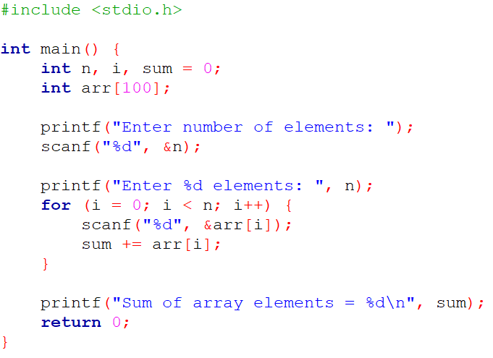Sample Output:
Enter number of elements: 5
Enter 5 elements: 2 4 6 8 10
Sum of array elements = 30

Lab Exercise 2: Maximum Element in an Array
Objective: To find and display the maximum element in an array.
Problem Statement: Write a C program to find the maximum value in a given integer array.
Algorithm:
- Start
- Read the number of elements n
- Read n elements into an array arr[]
- Initialize max = arr[0]
- Repeat for i = 1 to n-1:
- a. If arr[i] > max, then max = arr[i]
- Print max
- Stop
Program Code:
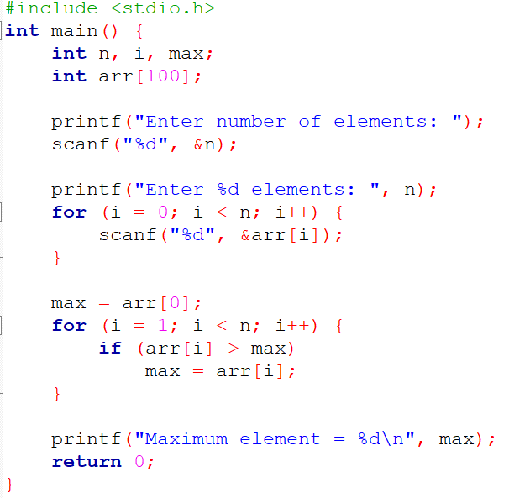
Sample Output:
Enter number of elements: 5
Enter 5 elements: 12 45 23 67 34
Maximum element = 67

Lab Exercise 3: Second Maximum Element in an Array
Objective: To find and display the second largest element in an array.
Problem Statement: Write a C program to find the second maximum element in a given integer array.
Algorithm:
- Start
- Read the number of elements n
- Read n elements into arr[]
- Initialize first = second = smallest value
- Repeat for i = 0 to n-1:
- a. If arr[i] > first, then second = first, first = arr[i]
- b. Else if arr[i] > second and arr[i] != first, then second = arr[i]
- Print second
- Stop
Program Code:
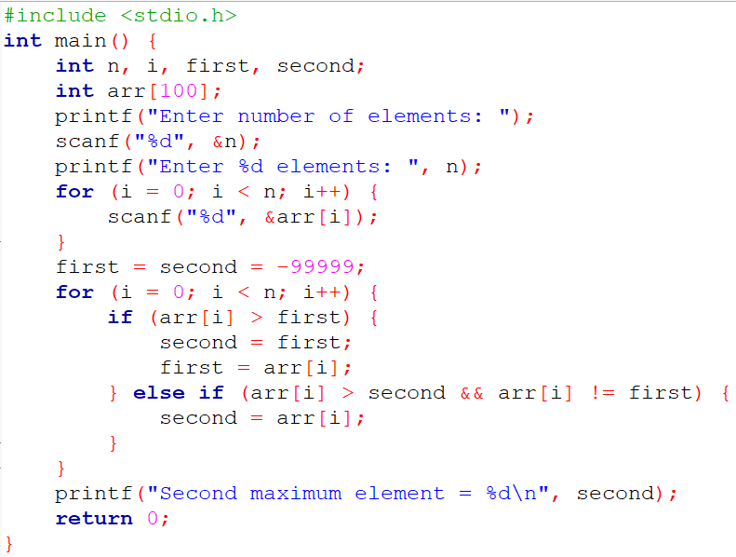
Sample Output:
Enter number of elements: 6
Enter 6 elements: 12 45 23 67 34 56
Second maximum element = 56

Lab Exercise 4: Reverse an Array
Objective: To reverse the order of elements in an array.
Problem Statement: Write a C program to reverse and display the elements of an array.
Algorithm:
- Start
- Read the number of elements n
- Read n elements into arr[]
- Initialize start = 0, end = n - 1
- Repeat while start < end:
- a. Swap arr[start] and arr[end]
- b. Increment start, decrement end
- Print reversed array
- Stop
Program Code:
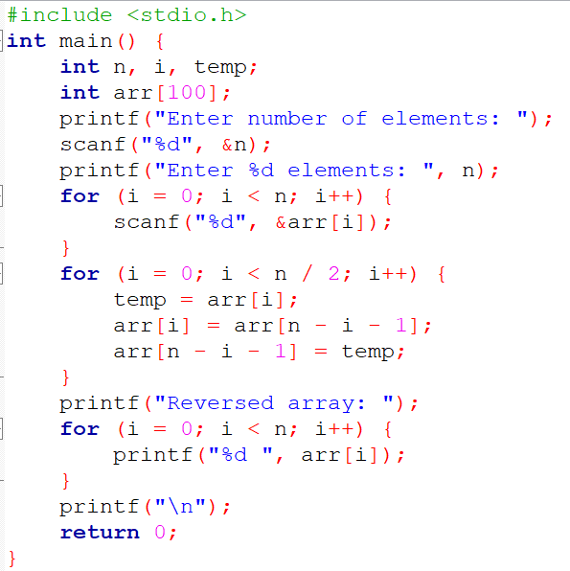
Sample Output:
Enter number of elements: 5
Enter 5 elements: 1 2 3 4 5
Reversed array: 5 4 3 2 1

Lab Exercise 5: Find Number of Duplicates in an Array
Objective: To count and display the total number of duplicate elements in an array.
Problem Statement: Write a C program to find how many duplicate elements exist in a given integer array.
Algorithm:
- Start
- Read the number of elements n
- Read n elements into arr[]
- Initialize count = 0
- Repeat for i = 0 to n-1:
- a. For j = i+1 to n-1:
- i. If arr[i] == arr[j], mark arr[j] and increment count
- Print count
- Stop
Program Code:
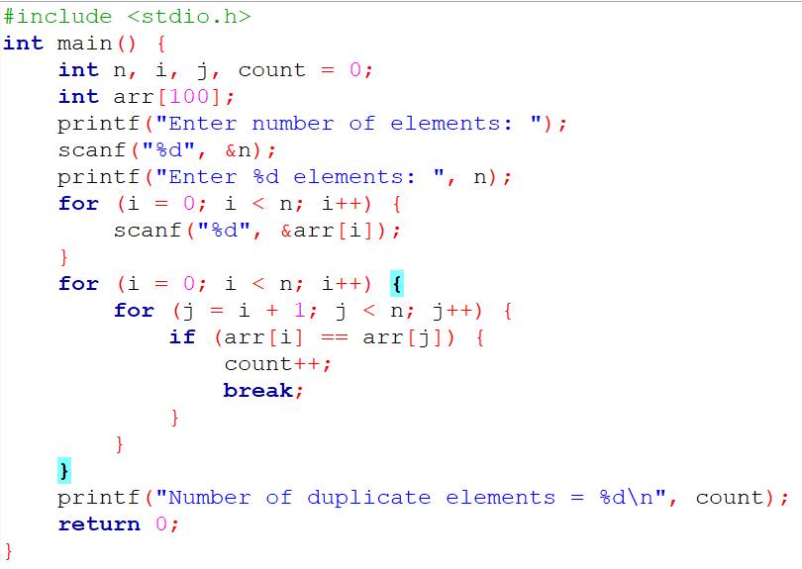Sample Output:
Enter number of elements: 6
Enter 6 elements: 2 3 4 3 2 5
Number of duplicate elements = 2

Lab Exercise 6: Frequency of Elements in an Array
- Start
- Read the number of elements n
- Read n elements into arr[]
- Initialize freq[] = -1
- Repeat for i = 0 to n-1:
- a. If freq[i] != 0, set count = 1
- b. For j = i+1 to n-1:
- i. If arr[i] == arr[j], increment count and set freq[j] = 0
- c. If freq[i] != 0, set freq[i] = count
- Print each element and its frequency
- Stop
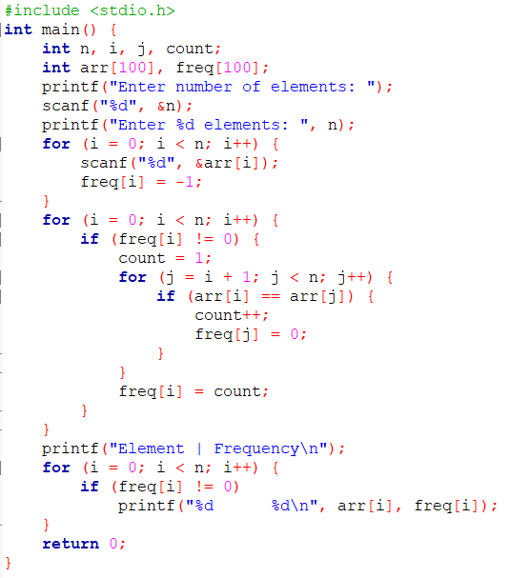
Sample Output:
Enter number of elements: 7
Enter 7 elements: 2 3 4 2 3 5 2
Element | Frequency
2 3
3 2
4 1
5 1

